

Electronic Document System

Work Instruction

Purpose

The purpose of this work instruction is to define the use of FileHold software for the handling and storage of controlled documents and quality records at SILQ.

This work instruction describes the steps on how to initiate a DCO, how to create a new document, how to revise a document, and how to release a document.

This work instruction describes steps for both the everyday user and for the Document Administrator who processes the DCOs.

Sections 6 through 10 is for all users.

Section 12 is for users assigned as DCO Approvers as well as for the Document Administrator

Sections 11 and 13 are for the Document Administrator only.

This work instruction provides a means to link an employee’s employee signature to their handwritten signature.

Scope

This work instruction applies to the use of the FileHold electronic system at SILQ.

Documents

Reference Documents

QM.SLQ001 Document Control

21 CFR Part 11 Electronic Records and Electronic Signatures

Appendices / Associated Forms / Templates

FM1-QM.SLQ001 Document Change Order Form

TMP1-QM.SLQ001 Controlled Document Template

FM1-QM.SLQ014 Electronic Signature Acknowledgement Form

Appendix 1 Creating or Changing a Document in the SILQ Electronic Document System

Appendix 2 Review & Approval of a DCO in the SILQ Electronic Document System

Appendix 3 Initiating a Training Workflow in the SILQ Electronic Document System

Definitions

Abbreviations / Acronyms

DCO: Document Change Order

DA: Document Administrator

General Definitions

Controlled Document: A document that requires formal control of revision, content, and release to ensure that the most current, approved revision is available for user.

Document Administrator (DA): The individual assigned the responsibilities to process DCOs and to add or change documents in the electronic document system. The document administrator controls access to the electronic document system and maintains all documents and records in accordance with the applicable procedures.

Document Change Order (form): The form used to add new or change existing documents in the document control system. The required information is listed in the form to manage the document control process and record the required approvals.

Document Number: A unique alphanumeric identifier that is used to track documents within the document control system.

Electronic Signature: A computer data compilation of any symbol or series of symbols executed, adopted, or authorized by an individual to be the legally binding equivalent of the individual's handwritten signature.

FileHold: Software based document management system used to electronically store controlled documents.

Revision Number: Represents the version of the document that allows the system to differentiate between the newest and previous older documents.

Responsibilities

It is the responsibility of all SILQ employees and subcontractors/consultants to comply with the requirements of this procedure.

It is the responsibility of the document administrator(s) (DA) to assign access to the system, to upload documents to the system, or make changes to existing documents in accordance with this procedure and QM.SLQ001 (Document Control SOP).

It is the responsibility of the document administrator to maintain access and security of the electronic document system in accordance with 21 CFR part 11.

Quality Assurance management is responsible for ensuring compliance with this document by SILQ personnel and sub-contractors/consultants.

Procedure: Accessing FileHold (all users)

If you do not have a FileHold user account:

Request an account from the Document Administrator. The Document Administrator will set up your user account and email you with your account information so you have access to FileHold.

Your User ID and temporary password will be contained in the email.

Open up your browser (Firefox or Microsoft browser) and access FileHold at the following link: https://edms009.fileholdcloud.com/FH/FileHold/WebClient/LoginForm.aspx

Type in your User ID and temporary password (For Domain: in the drop down, choose Local FileHold Account.).

Upon your initial log in, you will be prompted to change your password. Your FileHold password must be a minimum of 8 characters, must contain a number, at least one upper case letter, and at least one lower case letter.

Click “Log In”.

If you have a FileHold user account:

Open up your browser (Firefox or Microsoft browser) and access FileHold at the following link: https://edms009.fileholdcloud.com/FH/FileHold/WebClient/LoginForm.aspx

Type in your User ID and password (For Domain: in the drop down, choose Local FileHold Account if it is not already selected.).

Click “Log In”.

Procedure: Creating a new Document (all users)

This section applies to all FileHold users.

Log in to your FileHold account.

Go to LibraryQAForms, Templates, Travelers Templates.

Locate the Controlled Document Template, TMP1-QM.SLQ001.

Right click on the document name of TMP1-QM.SLQ001 Controlled Document Template to highlight it. Right click on the document so that a menu appears. Click on “Make a local Copy”.

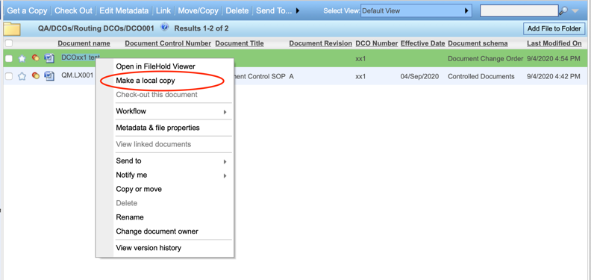

In web client: (using MicroSoft Edge browser) at bottom of Edge browser window, a window pops up with “What do you want to do with “document name”? Click Save.

In web client: (using Firefox browser) a window opens requesting what Firefox should do with the file, select “Save File”. Click Ok.

In web client: (using Chrome browser) download tab appears at bottom of browser; automatic download to your designated downloads folder.

Depending on your computer, the document will download into your “Downloads” folder.

Locate the template and rename the file with a descriptive name; perhaps at this stage, create a new folder for your new document on your desktop where you can also save the associated DCO that will be created at a later time (see Sections 8 & 9).

Now you can open your template and create your new document.

You can email the Document Administrator for a document control number at this stage, or you can wait until the document(s) are submitted to the Document Administrator for it to be assigned when the DCO is processed.

To get a copy of the DCO Form, see section 8.

To fill in a DCO Form, see section 9 along with QM.SLQ001 section 14.

To import DCO and associated documents into FileHold, see section 11 (applies to Document Administrator only).

To Review documents see Section 12.

To Release documents see Section 13 (applies to Document Administrator only).

Procedure: Obtaining Copy of the DCO Form (all users)

This section applies to all FileHold users.

Create a new folder on your desktop with an appropriate title to describe your project to make it easy to locate as you create DCO, fill it in, and create and/or revise other documents.

Log in to FileHold.

Go to LibraryQAForms, Templates, Travelers Forms.

Locate the Document Change Order Form, FM1-QM.SLQ001 (DCO Form).

Click on the document name of FM1-QM.SLQ001 Document Change Order Form to highlight it. Right click on the document so that a menu appears. Click on “Make a local copy”.

The document will be downloaded to your computer.

Locate the DCO form document on your computer and update the filename (save with a descriptive name so you can locate it, for example “DCOxxx project name.docx”). Move this saved DCO version into the folder that you created in section 7.7.

Now you can go to the project folder you created, open the DCO form and begin filling in the information. Please see Section 9 below along with QM.SLQ001’s section, “Completing DCO form” for assistance on how to fill in DCO Form.

Procedure: Completing DCO (all users)

This section applies to all FileHold users.

Please see QM.SLQ001 Document Control section 14.

Originator of the DCO opens up form created in section 8. Fill in fields as described in QM.SLQ001 Section “Completing DCO form”.

If additional risk management activities are required, originator of DCO is to reference or attach any applicable documentation.

If Originator chooses to attach: email the Document Administrator the document numbers/document names of the supporting documentation or attach documents to the email. Document Administrator will attach to DCO Approval workflow as supporting documentation.

If V&V activities are required, originator of DCO is to reference or attach any required V&V documentation for review.

If Originator chooses to attach: email the Document Administrator the document numbers/document names of the supporting documentation or attach documents to the email. Document Administrator will attach to DCO Approval workflow as supporting documentation.

If material disposition required and rework required, originator of DCO is to attach rework instruction and reference in the ‘Additional Info’ field of the DCO.

If Originator chooses to attach: email the Document Administrator the document numbers/document names of the supporting documentation or attach documents to the email. Document Administrator will attach to DCO Approval workflow as supporting documentation.

Once DCO Form has been completed, email it to the Document Administrator along with the document(s) listed within the DCO.

Document Administrator (DA) fills in fields as described in QM.SLQ001 Document Control section “Completing DCO form”.

Fill in DCO number.

Fill in proper Approval names per document types listed.

Procedure: Changing Existing Documents (all users)

This section applies to all FileHold users.

Navigate to the appropriate document type folder within FileHold where the document(s) you wish to revise is located.

Click the document name so that it highlighted and right click so that a menu appears, select “Make a local copy”. The copy will be downloaded to your computer’s default downloads folder.

Navigate to the downloads folder on your computer to locate the document you are going to revise. Move document you are going to revise/redline so that it is in the same project folder as the DCO form so everything stays organized and easy for you to find.

Update the filename of your document to add the word “redline” to it, for example “FM1-QM.SLQ001 B Document Change Order Form_redline.docx”.

Open the document you want to revise. Click on the “Review” tab in Word and turn Track Changes on so that your updates are easily visible. Edit your document.

If you have more documents, follow above steps until all the documents you want to revise are updated and ready to send to the Document Administrator.

Email all of your documents to the Document Administrator for DCO processing.

Create DCO if not completed yet and email to Document Administrator. Please see Section 7 and/or Section 8.

Procedure: Initiating DCO Approval workflow (Document Administrator only)

This section applies to the Document Administrator only.

After the Originator completes documents and has emailed them to the Document Administrator, the Document Administrator will import them into FileHold.

Create a new project folder on local PC to contain all DCO documents.

Log into FileHold.

Go to LibraryQADocument Control LogsDocument Control Logs folder

Check out the DCO log and the Document Number log and/or Part Number Log.

Click on title of log, on menu select “Check out this document”. In Firefox browser, a window opens requesting what Firefox should do with the file, select “Save File”. Click Ok. Your file will be saved to your Downloads folder.

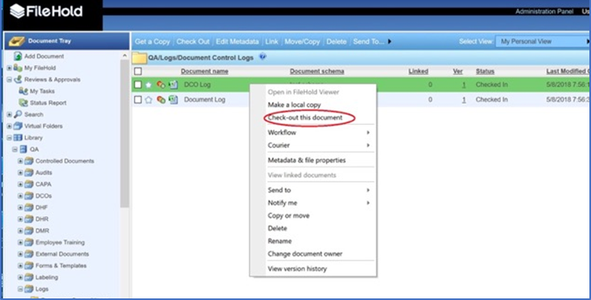

Open the DCO log and assign the next sequential DCO number. Open the DCO document and type in the assigned number into the DCO form. Enter the documents listed on the DCO form into the DCO log. Update the DCO form filename to include the DCO number, for example (DCO001.docx).

Open the Document Number Log, ensure the correct document control numbers and titles are listed in the submitted DCO form along with the accurate revision levels. Assign document numbers for initial release documents, if not yet assigned.

In the DCO form, type in the assigned DCO number. Update the filename of the DCO to reflect assigned number. Update project folder on your local PC with DCO number so that can keep everything organized and easy to locate.

In the DCO form, type in the approvers according to document types listed on the DCO. Type “View sign-off sheet” within the Signature/Date field next to each approver. Refer to QM.SLQ001 Document Control Appendix 1.

Navigate to the QM.SLQ001 folder, click on QM.SLQ001 Document Control. On menu that appears, select “Make a local copy”.

If there are multiple document types on the DCO (which prompts different approval groups), the original DCO form will need to be copied to create a separate DCO for each approval group.

Example: DCO001 has the following 3 documents listed:

SOP/QM (approval group D),

Work instruction/QM (approval group C),

And Design Document/Software (approval group A).

Three DCOs need to be generated. DCO001, DCO002, DCO003. (Each DCO will have its own DCO Approval workflow.)

Check DCO for errors, any discrepancies.

Check in the DCO log and the Document Number log and/or Part Number log to FileHold.

In FileHold, click on title of log, on menu select “check-in this document”. The “check-in files to the Library” window opens to the right side of the browser. Click “browse…” In the window that opens, navigate to the folder where the checked-out log is located. Click on the log to select it. Click Open. Click Check In.

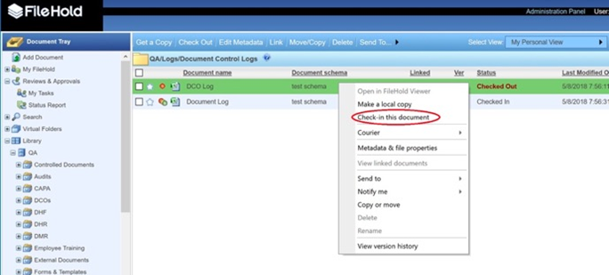

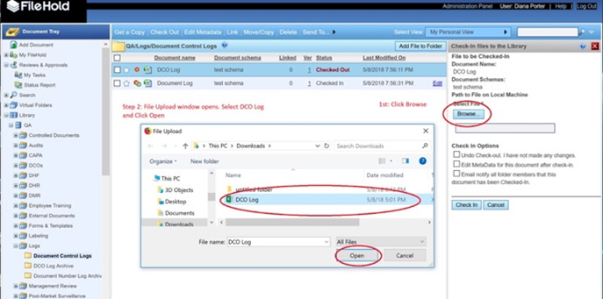

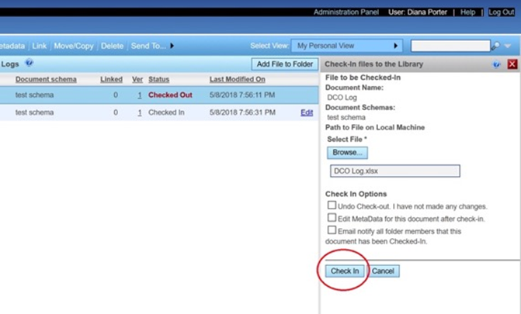

Review each of the new or revised documents submitted to make sure there are no questions, or to correct minor errors or return to the Originator via email for corrections.

Once DCO form and associated documents are ready, go to Library QA DCOs Routing DCOs

Click on the “Routing DCOs” folder. On the menu that appears, select “Add Folder”. (Note: If no “Routing DCOs” folder is present, right click on DCO drawer and select “add folder”.) In the “Add Folder” window that appears, type in the assigned DCO number in the Name field (example, “DCO001”). Make sure the Default Schema is set to “Controlled Documents” in the drop-down menu and that the Folder Group drop-down menu is set to “Routing DCOs”. Click “Next”. In the Security section, be sure that the appropriate members who will be reviewing and approving the DCO show up in the “Current Members of Folder”. (If you need to update, click “Add Groups” and will see all move over to the right “Current Members” area.) Click “Save”. The new folder will appear under the “Routing DCOs” folder group.

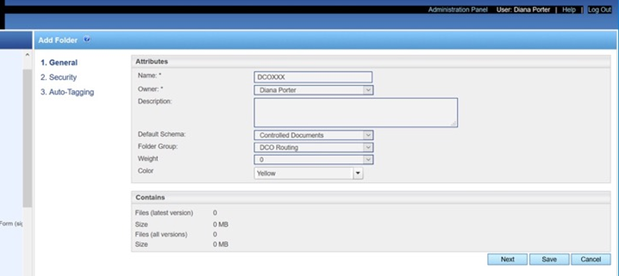

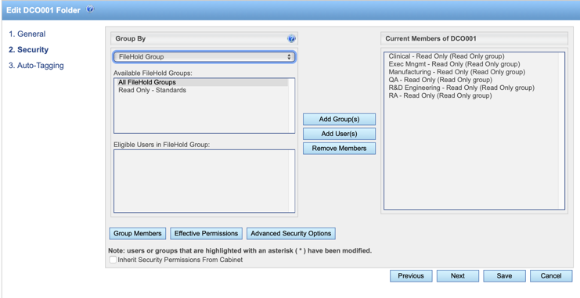

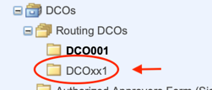

Within the new routing DCO folder, click on the “Add File to Folder” button in the upper right of the window. An “Add File to DCOxxx” window will open along the right side of the browser. Select Document Schema “Controlled Documents” in dropdown menu. Click on Browse button. This will open window where you can locate the folder containing the DCO form and associated documents you want to import. Click on the initial controlled document you want to import. Click “Choose” (or “Select” depending on your browser). Note: Don’t select the DCO form first because you want the initial document imported to show up in the workflow notification email. This helps approvers know what they have to approve. If you select the DCO form as the initial document, it doesn’t provide helpful information to approvers of what is attached to the workflow.

The document will be shown in the “Select File” field. Fill in the required fields in the “Add File to DCOxxx” window. Click “Save”. The document will appear in the DCO routing folder.

Repeat for each document until all documents listed on the DCO form are added into the routing DCO folder.

For the DCO document: in the “Add File to DCOXXX” window that opens, select Document Schema “Document Change Order” in the drop down menu. Click “Browse” button and locate the DCO form you want to import. Click “Choose”. Fill in required metadata fields. Click “Save”.

Go to the routing DCO folder where all of the DCO documents are now located (should still be in that window after last document added in prior step).

Now you can initiate a workflow for DCO Approval. With the contents of the DCO folder showing in the window, click on the check boxes to left of each document that you want to include in the workflow. Right click on the group and on the menu that appears, select Workflow Initiate DCO Approval.

If you need to add supporting documentation, prior to initiating workflow, add a copy of each support document to the appropriate Routing DCOs folder to ensure that all approvers have permission to view the document.

Select all documents EXCEPT for the supporting document(s).

Select Workflow Initiate DCO Approval with Supporting Documentation.
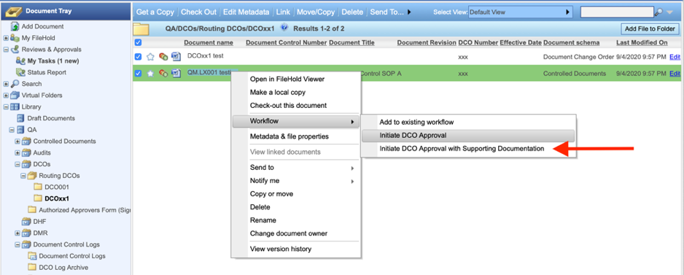

The “Initiate DCO Approval Workflow” window will appear.
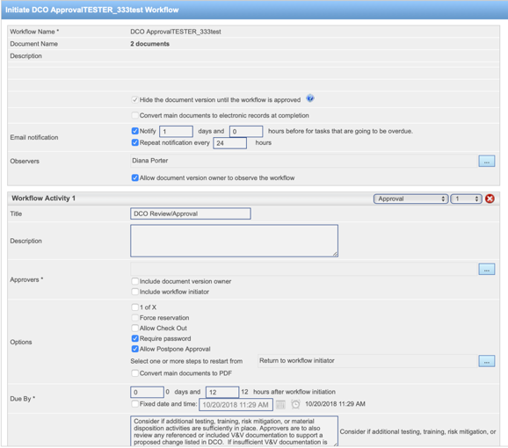

In the very top window where it lists the Workflow Name, next to “Observers” click on the blue button with the three dots located to the right side of the window.

This will open up a “Select Workflow Observers” window. In the “Eligible Users In FileHold Group” window, select the originator and all approvers, then click on “Add User(s)” button so that they are moved into the “Current Observers” window. (This is to ensure that everyone will receive an email notification from FileHold letting them know that the workflow is complete and documents have been released.)

Update Review/Approval activity in the “Approvers” section of Workflow Activity 1; (Workflow Activity 2 if adding supporting documentation) to include the approvers that are listed on the associated DCO by clicking on the button with the three dots to the right (be sure to include the DCO’s Originator as an approver) in the Approvers row.


This will open up a “Select Task Participants” window. In the “Eligible Users In FileHold Group, select the approvers, then click on “Add User(s)” button so that they are moved into the “Current Participants” window.
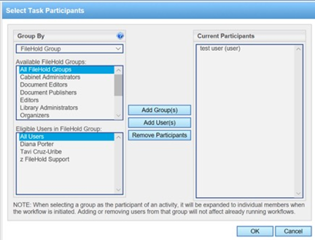

Update the “Due by” sections accordingly so that email alerts are generated according to DCO’s effective date (so approvers get timely reminders).
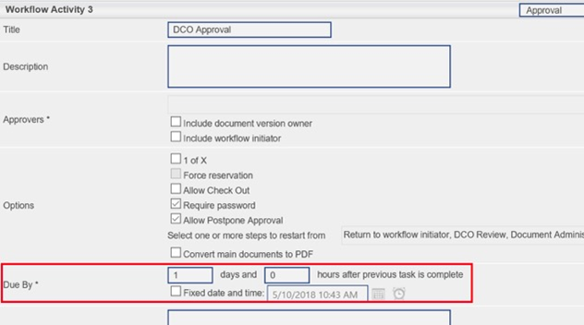

When all sections are completed, click the OK button at the bottom of the window.

If you selected the workflow to add supporting documentation: Initiator will receive email from FileHold alerting them that they have a review task assigned: to add supporting documentation. Go to each document that is a supporting doc in routing DCO folder, right click on the document and select Workflowadd to existing workflow. The “Add Documents to Existing Workflow” window opens. Select the appropriate DCO Approval workflow by clicking in check box to left of it. At the bottom of the window, there’s an “add the selected documents as” section: be sure the button for “supporting documents associated with the workflow” is selected. Click Ok. Repeat for each document that you need to add. Now, if you go to the My Workflow Tasks window, and click “show documents”, the supporting document(s) is added and you can see that it shows as “supporting” in the “Main/Supporting” column. DA can now click the checkbox next to the Review task, then click on the “Complete task” link at top of window. Click on “reviewed” button. Enter in comments if desired, and click “reviewed” button once again at bottom of window so that the workflow progresses on to the Approvers activity. (Observers will receive FileHold email alerting them that a supporting document was added to workflow).

Now each assigned approver will receive an alert in FileHold that they have a new task within the “Reviews and Approvals” section. My Tasks will show “1 new” in bold text. Each approver will also receive an email workflow notification.
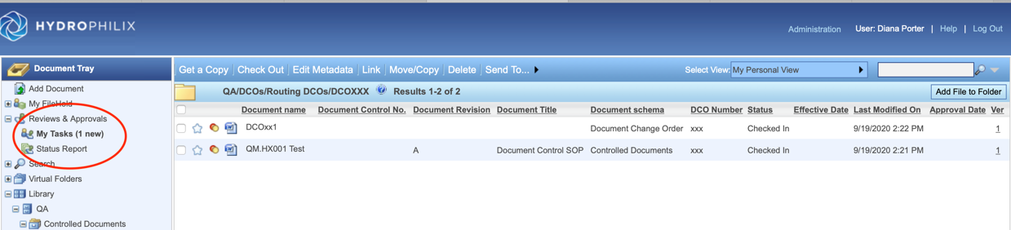

Procedure: Review DCO Contents (Approvers and Document Administrator)

This section applies to users assigned as DCO approvers and to the Document Administrator.

Approver receives a “FileHold workflow notification” email alerting them that they have an approve task assigned.

Approver logs in to FileHold.

Click on “My Tasks”. The “My workflow tasks” window will open. Click on the appropriate DCO task’s “Show Documents” link (if you have multiple tasks already listed) to the right so you can review documents.
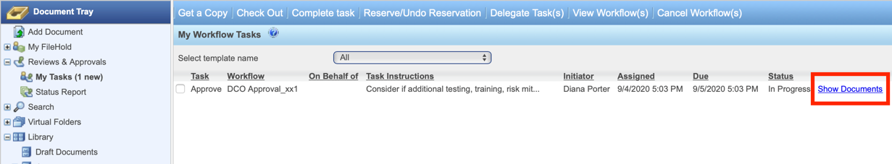

The “Documents associated with DCO approval workflow” pane will appear at bottom of window listing the DCO documents.
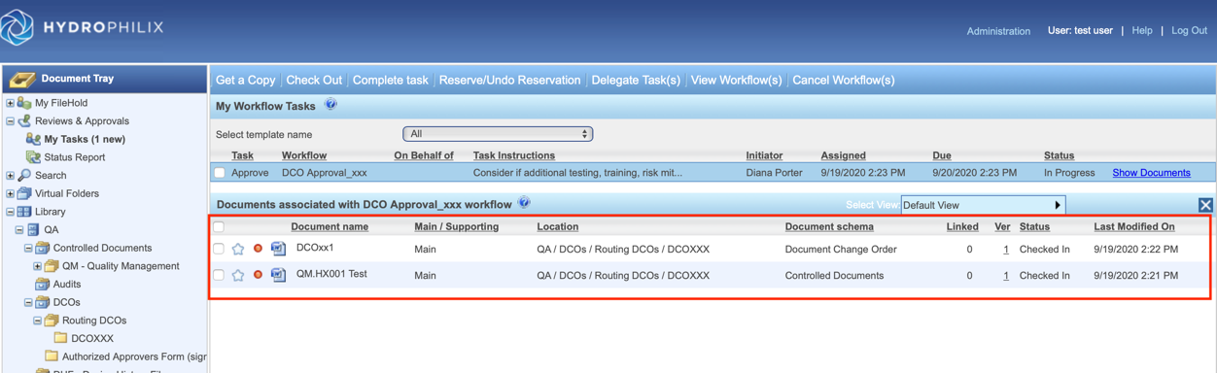

To open the DCO form to review, click to highlight it and right click to open menu. Select “Make a local copy”. A copy is downloaded to your PC. Locate DCO form and open the file to review.
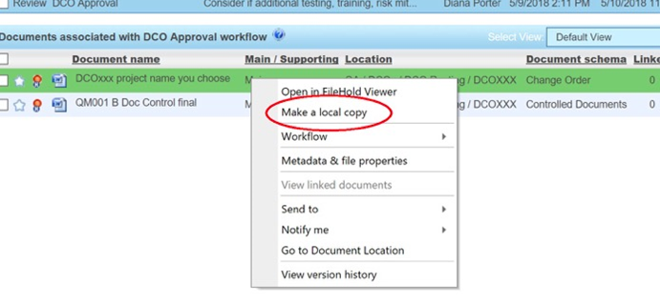

Review DCO form contents.

If applicable, review V&V documents and material disposition sections to review all issues. Note: if you need to email the originator to request additional information, their name can be located on the DCO form.

If applicable, support documentation will be attached.

For the other DCO documents, right click on them and select “Make a local copy”.

Depending upon how you are accessing FileHold, where the local copy is downloaded will vary. You’ll want to make note of where it is downloaded so you can locate it easily.

Firefox: Window pops up with option to open or save file. You can first opt to open file and review. If no need to update, you can simply close file. If you need to add an update, you can save file to your local PC where it will be copied into your “Downloads” folder.

It is recommended that you choose “make a local copy” for redlined documents because in the FileHold viewer the redlines do not show up (the changes show up as already accepted so cannot easily view what has been updated).

Open each individual document on your local PC and review.

If you need to modify document, be sure that “track changes” is turned on in Word. Make any necessary changes. Update the filename by adding your initials (for example, “TMP1-QM.SLQ001 document_redline_DP.docx”).

If all documents approved: go back to FileHold and to “My workflow tasks” window. Click in the checkbox next to the workflow task you are reviewing so it is checked. Click “Complete task”.
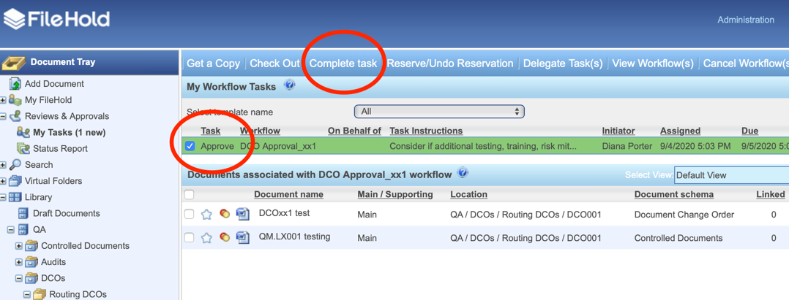

The “Submit approval” window will open. Select the green “approve” button.
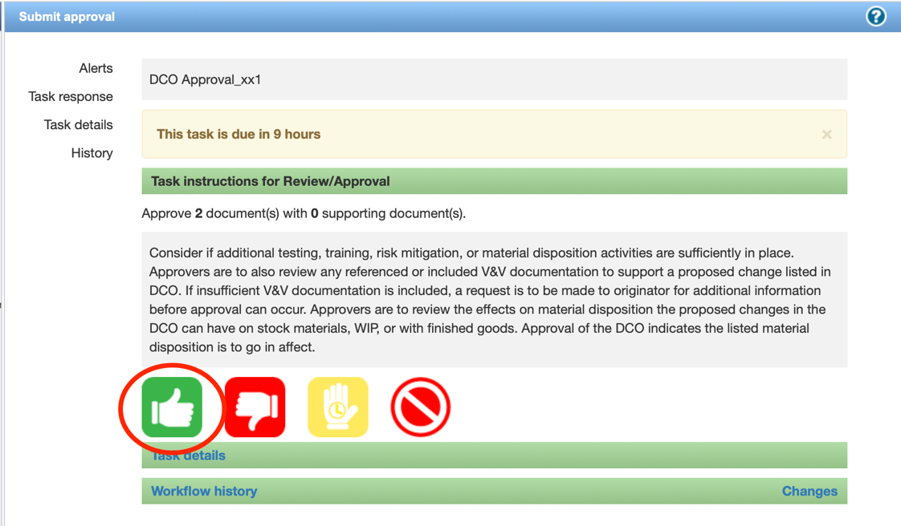

The “Complete approval submission” section will appear along with a password signature field. Fill in your password and click the green “approve” button.
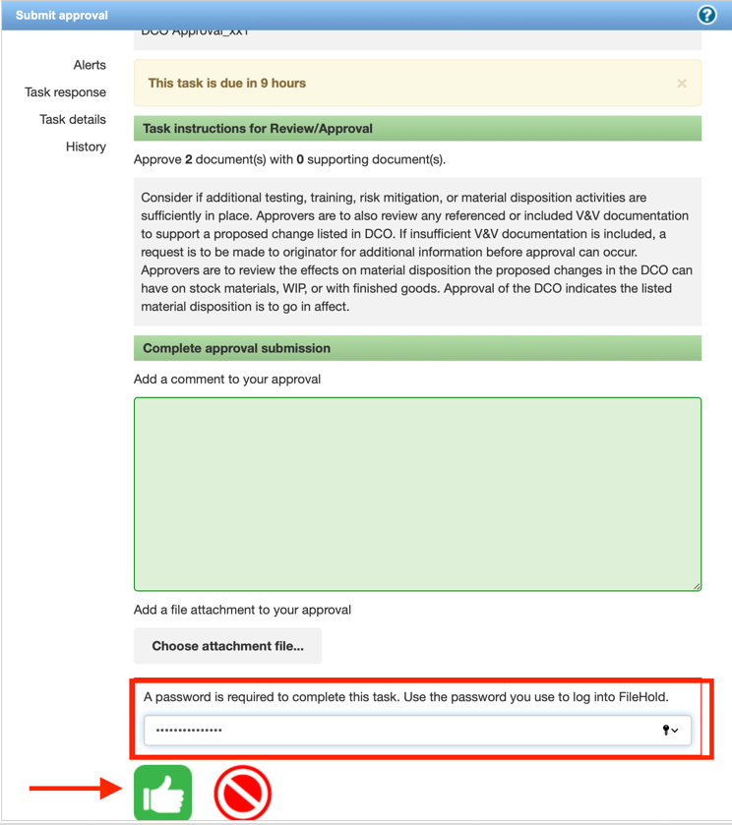

If reviewer requires changes due to discrepancies or disagreement with the document content:

If you updated a document during review: go back to FileHold and to “My workflow tasks” window. Click the checkbox next to workflow task you are approving so it is selected. This will make the “Complete task” button active. Click to submit approval. The “Complete task” window will open. Click yellow “Postpone approval” button.

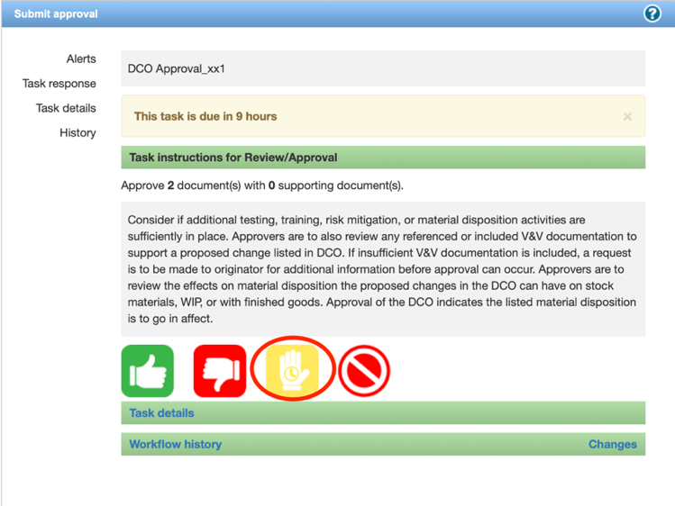

Enter in comments about your suggested changes (1). Then, click the “Choose attachment file…” button to locate your redlined document (2).

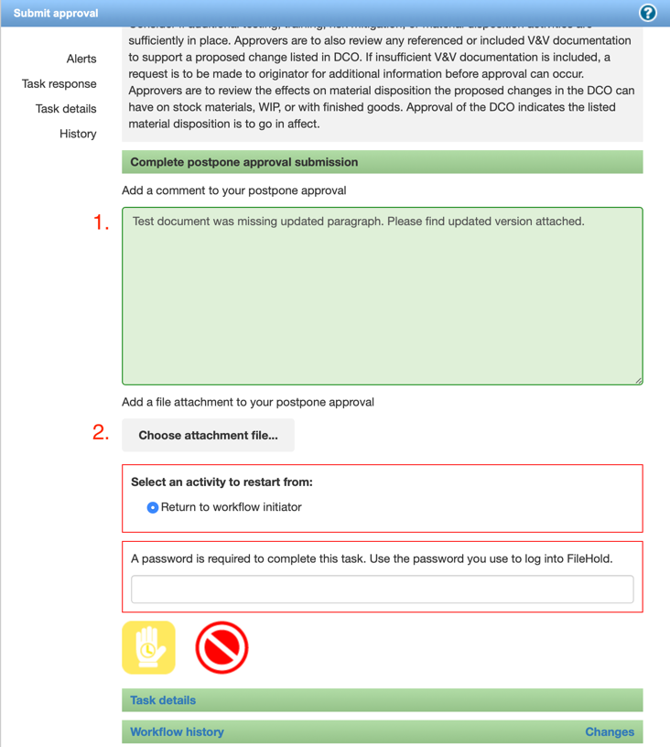

Window will open; select redlined document (3.) Click Open/Choose (4). Fill in password (5).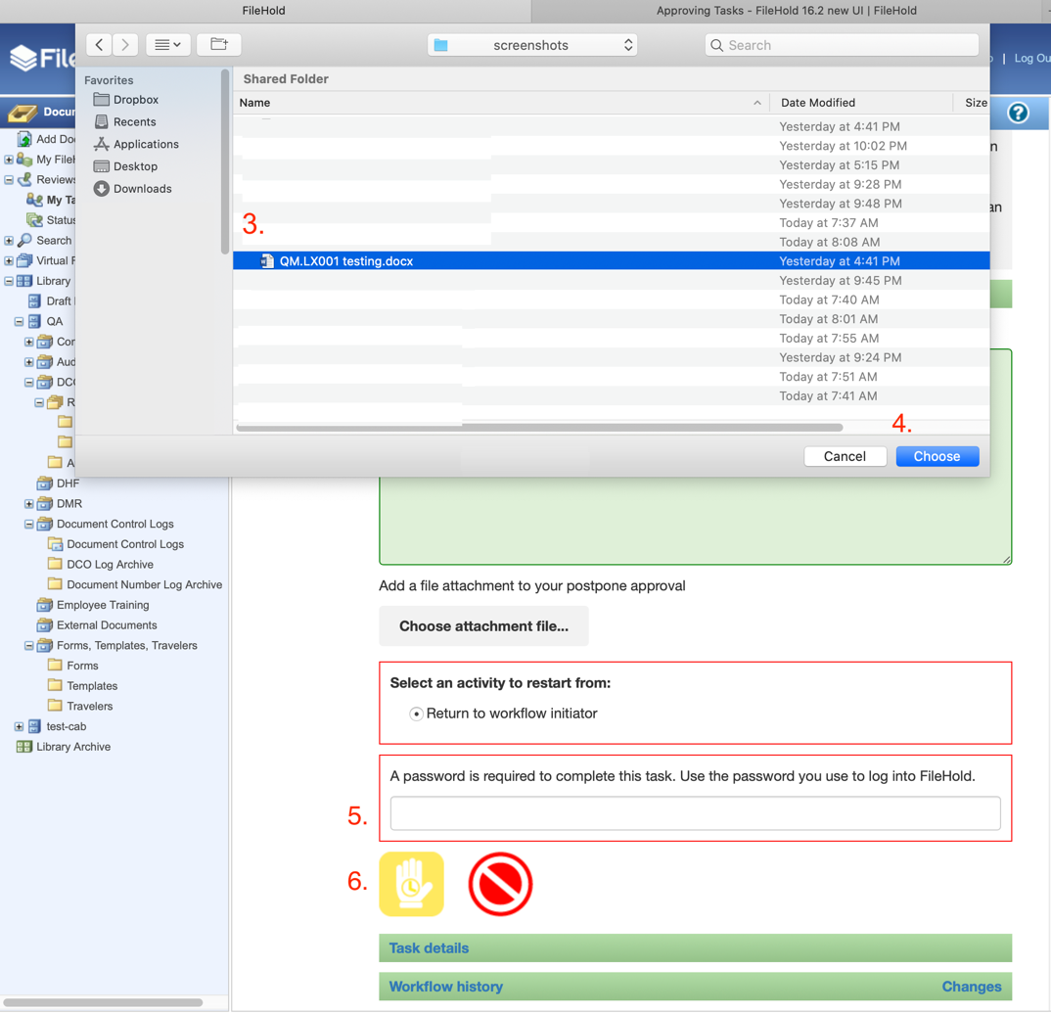

Click yellow “postpone” button (6).

If you have more than one updated redlined document (FileHold only allows one attachment here), email them to the Document Administrator (making sure to reference the DCO number so they know which DCO the document belongs).

Note: If approver inadvertently selects red “I Do Not Approve” button the workflow is cancelled. All associated documents will then need to be checked out to initiate a new revision in FileHold (FileHold won’t allow a workflow to be created on the rev that was attached to a document where “I do not approve” was submitted).

DA receives email notification that approval was postponed.

DA logs into FileHold and goes to “Status Report” window to read comments/look for attachments.

If there’s an attachment, the DA downloads a copy to DCO project folder on local PC that contains updated document(s) for the current DCO. 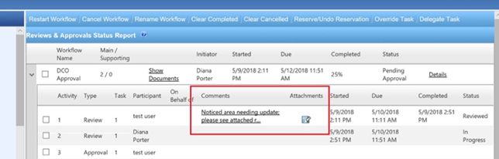

The DA emails the originator regarding the approver’s comments/ updates, attaching the reviewers redlines, if any.

If Approvers have questions on V&V such as insufficient V&V documents, they are to email originator for additional information before approval can occur.

Approvers and originator work together to update documents as needed.

Originator emails DA to let them know all issues have been resolved; documents updated to reflect additional changes, etc. The updated documents are attached to the email.

DA goes to DCO folder and checks out document(s) that have been updated by approver.

Updated documents are then checked in to FileHold. Note: update filename of each updated document with a ‘2’ to show it has been updated, for example “FM1-QM.SLQ001 DCO_redline2.docx”.

DA goes to each document within the DCO that is routing, right clicks on each document to select “Check-in this document”. The “check in files to library” panel opens to right of browser window. Click on “browse” and locate the updated redline. Click “Check In”. 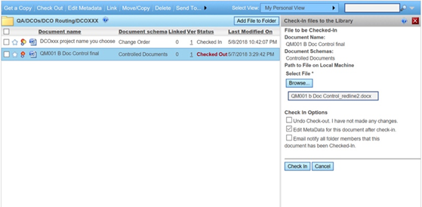

Document Administrator checks out the DCO form and the DCO log. Update DCO number with alpha character (ex. DCO001A. Open DCO form and update the DCO number to add the alpha character. Update the DCO log with the updated DCO number so that it also reflects the alpha character. Check the DCO form and the DCO log back in to FileHold. Update metadata for DCO form in order to update DCO number with alpha character. Click “save”. 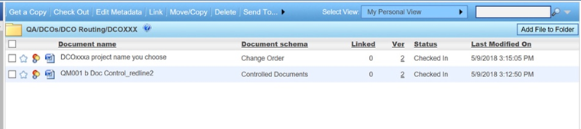

Screenshot above shows updated DCO with alpha character and updated redline.

Now DCO Approval workflow will need to be restarted so that all approvers can review the recent updates that were made. Document Administrator goes to Status Report and clicks the down arrow next to appropriate DCO to select it. Click the check box next to one of the approvers for Activity 1 Approval to restart the approval process. Click the “restart workflow” link at top of window. An information window opens alerting you that you are about to restart the DCO workflow. Click OK. The DCO Approval workflow immediately restarts and all participants will receive an alert that the workflow has been restarted.

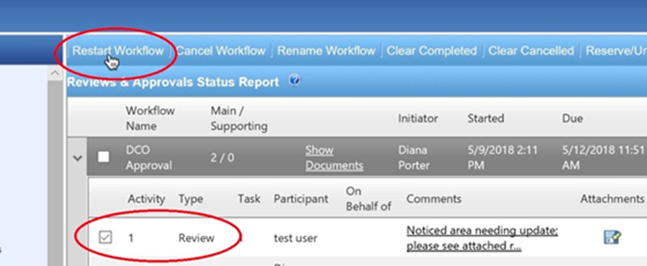

Each approver logs in to FileHold, and repeats steps outlined above in sections 12.4 through 12.9 to review updated documents. Repeat as necessary if any subsequent changes are made.

Once all approvers have submitted their approval through FileHold, the Document Administrator will receive a FileHold alert for their approval/document release activity step.

Approvers are to make sure to delete all local copies so that there are no duplicates.

Approvers’ participation is complete at this stage.

Participants in the workflow (those listed as “Observers”) will receive an email from FileHold alerting them that the workflow is complete after the Document Administrator completes their steps in section below. Receipt of the Workflow Completed email lets approvers know documents are released.

If DCO can’t be approved: Document Administrator goes to the appropriate DCO folder. Check out the DCO. Update file name with “cancelled” (for example, DCO004 cancelled.docx”) Open DCO form and insert watermark or stamp “DCO Cancelled”. Insert line through the approvals box. Check DCO in. Make notation within DCO log that DCOxxx was cancelled. DCO filed in “DCO Complete” folder.

Procedure: Release of documents (Document Administrator only)

This section applies to the Document Administrator only.

Document Administrator/Initiator receives email from FileHold that DCO has been approved by all participants and that the final DCO Approval workflow activity task to add in effective date to the metadata and release documents has been assigned.

Document Administrator logs into FileHold and navigates to appropriate routing DCO folder.

Document Administrator right clicks on the DCO form within the DCO folder; when menu appears, click on WorkflowView Sign-off Sheet to ensure all approvers have signed.
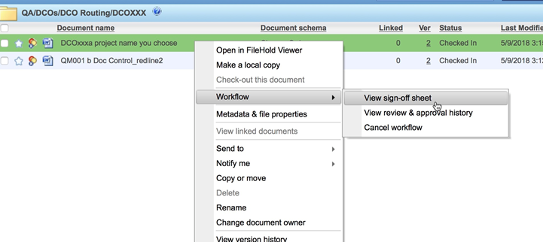

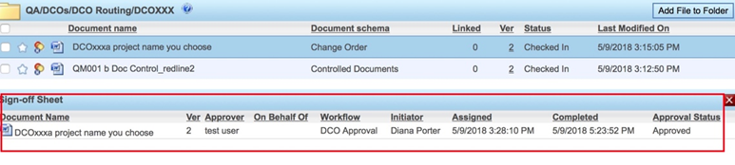

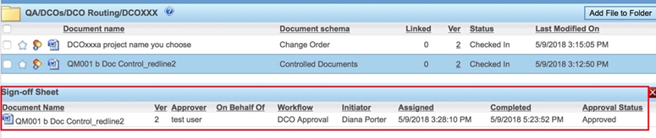

Effective Date to be entered into the metadata of the DCO form and each document listed on the DCO. Right click on the DCOxxx form and click on “Metadata and file properties”. The Metadata fields window opens on right side of browser. Click Edit. Select the Effective Date so that it is added within the appropriate metadata field (Effective Date is filled in on DCO form by the Originator in the field “Req. Effective Date: R +”. In this example, the R+ is “2”; Release Date is the date the final approver signs) Repeat for all documents attached to DCO.
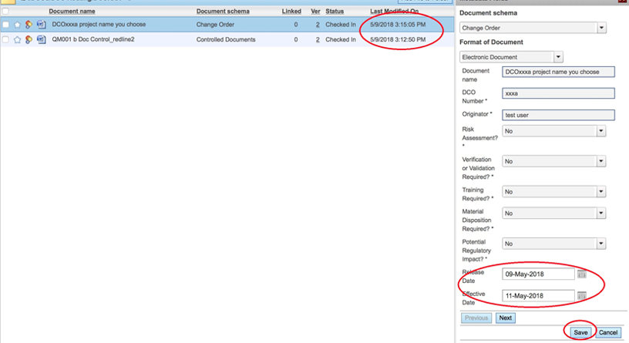

Document Administrator checks to see if training is required, and if materials disposition is indicated:

If training required: Document Administrator notifies training coordinator of the documents and type of training / if effectiveness checks are required via email. Document Administrator emails copy of the DCO by right clicking on the DCO, on menu that appears, select Send to email. Note: Alternatively, DA may opt to “take a copy” of the DCO form and send via external email.

If materials dispositon is indicated: Document Administrator emails a Manufacturing and/or QA representative with the changes by emailing a copy of the DCO form. Document Administrator right clicks on the DCO, on menu that appears, select Send to email. Note: Alternatively, DA may opt to “take a copy” of the DCO form and send via external email.
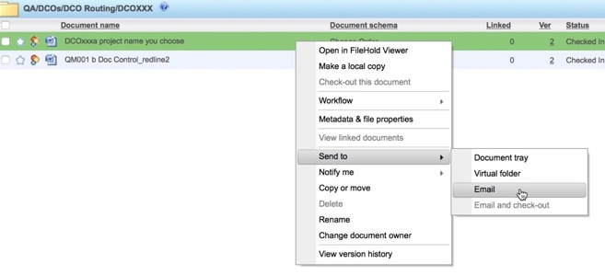

Document Administrator goes to the routing DCO folder to check out and make final versions. Right click on one of the documents to create its final version. Select “check-out this document”.

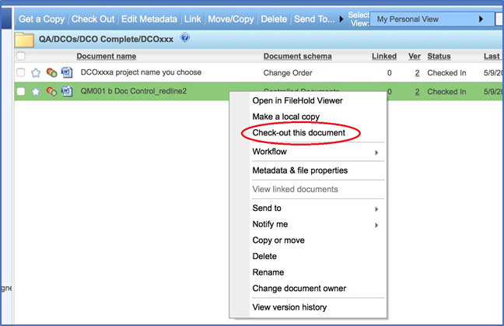

Document is downloaded to your computer. Locate document on your local PC. At this stage, it is recommended you create a new folder named with this DCO number so that you can place all of the documents in one easy to find location. Move document into this project folder.

If it is an initial release document, with the document open, type in the Effective Date and type in the Revision. Save. Update filename if necessary.

For Policy or Standard Operating Procedure Document Categories: Create pdf version. In PDF version, insert “Master Copy” stamp/watermark. (Word version does not receive stamp/watermark.)

For Forms, Templates, Travelers: Word version has no stamp and is used by employees to make their records or documents. A copy of Word version is placed in appropriate “Forms”, “Templates”, or “Travelers” folder.

If it is a revised/redlined document, with the document open, accept all changes. Make sure revision level is updated accurately in the header. Type in the Effective Date. Make sure all changes accepted properly, formatting updated properly, etc. Save. Update the filename to show current revision level along with removing “redline”, ex: “QM.SLQ001 B Document Control SOP.docx”.

For Policy or Standard Operating Procedure Document Categories: Create pdf version. In PDF version, insert “Master Copy” stamp/watermark. (Word version does not receive stamp/watermark.)

For Forms, Templates, Travelers: Word version has no stamp and is used by employees to make their records or documents. A copy of Word version is placed in appropriate “Forms” or “Templates”, or “Travelers” folder.

Repeat for all documents listed in the DCO to create all final versions.

Check out the DCO log and the Document Number Log and/or Part Number Log. Update with DCO and document effective dates, revision levels, etc.

Check in DCO log and the Document Number log and / or Part Number Log.

Now want to check-in the final document versions back into FileHold and into the appropriate routing DCO folder.

In FileHold, right click on the document, click “check-in”.

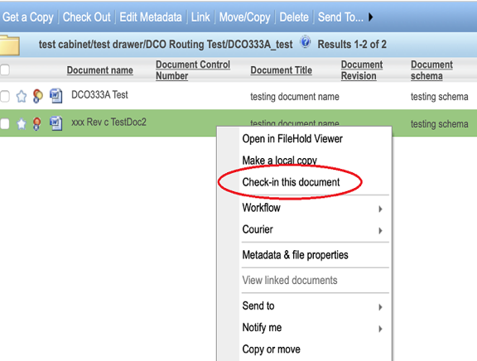

Click Browse button to locate file. Select file and click choose. Click Check in.

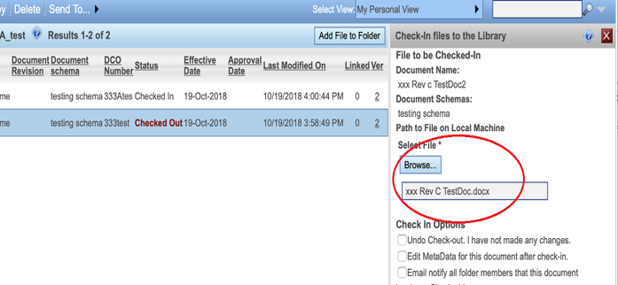

File is checked back in. Repeat check in process for all documents.

PDF versions (for Policy and Standard Operating Prodedures containing the “Master Copy” mark, for example) will have to be added to the appropriate Routing DCO folder. Click on “Add File to Folder” at top right of FileHold window.

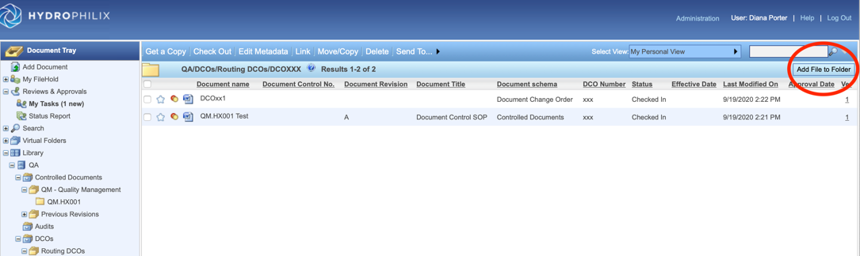

The “Add file to DCOxxx” window opens on right side of window. Select “Controlled Documents” for document schema. Click on Browse to locate pdf file; click on pdf document to select it and click “choose”. The pdf file will show in the “Select File” field. Fill in metadata to match Word version. Click “Save”. PDF is added to routing DCO folder.

Note: Steps 13.11 through 13.17 below to take place on effective date listed on the DCO form.

Now, if there are superseded versions to move, want to move them to appropriate previous revision folder. Will also need to open them up and insert the ‘Previous Revision’ watermark or stamp. In the folder of the superseded versions: click in the boxes to the left of each document so that they are selected. Right click on the document name. On the menu that appears, select “copy or move”.

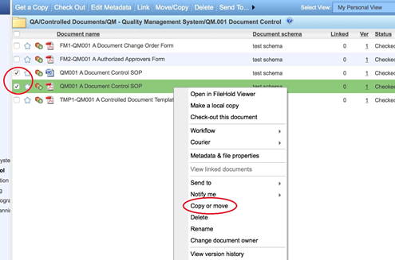

On the window that opens, select the “move” option. Click OK. On the window that opens, select the appropriate document type within the “Previous Revisions” folder. Click OK. All the selected documents will be moved. Note: If there are forms and/or templates or travelers that have been superseded, be sure to also move them out of the current “Forms” and/or “Templates”, or “Travelers” folder.

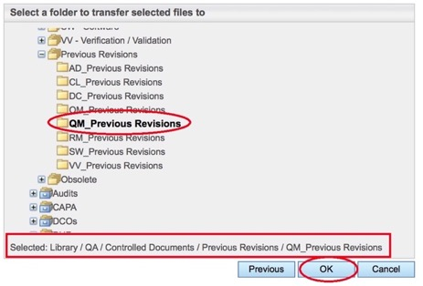

Go to the appropriate superseded document(s) in the Previous Revisions folder and right click it to check it out. After it is downloaded to your local PC, open the document and insert watermark/stamp “Previous Revision” (for PDF version that has “Master Copy” mark, delete the “Master Copy” mark and replace it with “Previous Revision”. For Word version that has no mark, insert “Previous Revision” watermark using Word). Save the document. Check it back in to FileHold.

Repeat for all documents that have been superseded by the DCO.

If the document is “Obsolete”, will want to move them to appropriate obsolete folder. Will also need to open them up and insert the ‘Obsolete’ watermark or stamp. In the folder of the obsolete versions: click in the boxes to the left of each document so that they are selected. Right click on the document name. On the menu that appears, select “copy or move”. On the window that opens, select the move option. Click ok. On the window that opens, select the appropriate document type within the “Obsolete” folder. Click ok. All the selected documents will be moved. Be sure to move any forms, templates, and/or travelers if applicable. Go to the document in the Obsolete folder and right click it to check it out. After it is downloaded to your local PC, open the document and insert watermark/stamp “Obsolete – Effective Date DDMMMYYYY”. Save the document. Check it back in to FileHold. In the metadata, choose “obsolete” for revision in the drop down menu. Repeat for all documents that have been obsoleted by the DCO. Be sure to go to the document’s “previous revisions” folders and move all of these now obsolete documents in to the “obsolete” folder. Delete the obsolete document’s folder in the library, as appropriate.

Copying final version to the main library for documents that are initial releases in the DCO and for the final versions of the latest approved revisions:

Go to the routing DCO folder and to the current DCO. Right click on the document, select “Copy or move”. Select “Copy”. (Note: For “Master Copy” .pdf versions, select “Move”.)

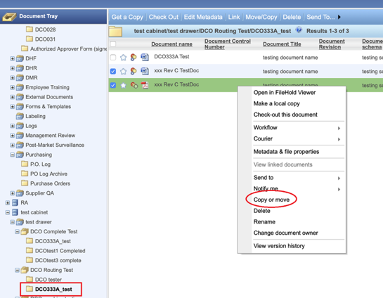

Click ok. Select the appropriate document destination folder (QM, RM, VV, etc.) to copy/move the final document. Click OK. For “Master Copy” pdf versions, on the window that opens, select the move option. Click ok. Select the proper document type folder (QM, RM, VV, etc.) to move the final document. Click ok.

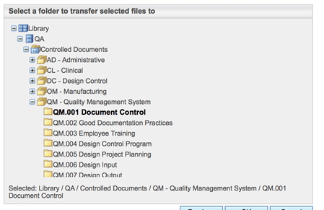

The file will be copied/moved into folder. Repeat for all final documents in the routing DCO folder.

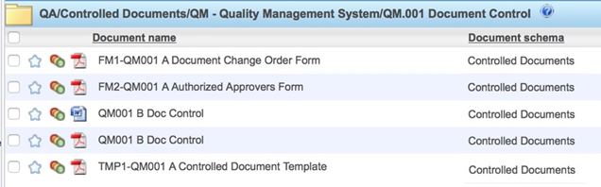

Move the Master Copy PDF’s to the appropriate document type folder listed in the appropriate drawer. (Note: If a document has a PDF version created during release process, select “move” option.)

Copy the final documents to the appropriate document type folder listed in the appropriate drawer.

Word versions of Forms/Templates/Travelers: Forms are copied to the “Forms” folder; Templates are copied to the “Templates” folder; Travelers are copied to the “Travelers” folder.

Document Administrator clicks on “My Tasks” to open the My Workflow Tasks window and clicks on the Task “approve” check box next to the appropriate DCO workflow. Click “Compete task”. Click on the green “approve” button. Password field appears: Enter in password. Click on the green “approve” button. Workflow completed email notification will be received by all individuals listed as “Observers” in the workflow.

DA right clicks on the routing DCO that was just approved and selects “Move Folder”. The “Select a destination Drawer or Folder Group to Move the Folder to” window opens. Click on the “Completed DCOs” folder group so that it is selected and you can see the destination file path confirmed at the bottom of the window. Click OK.

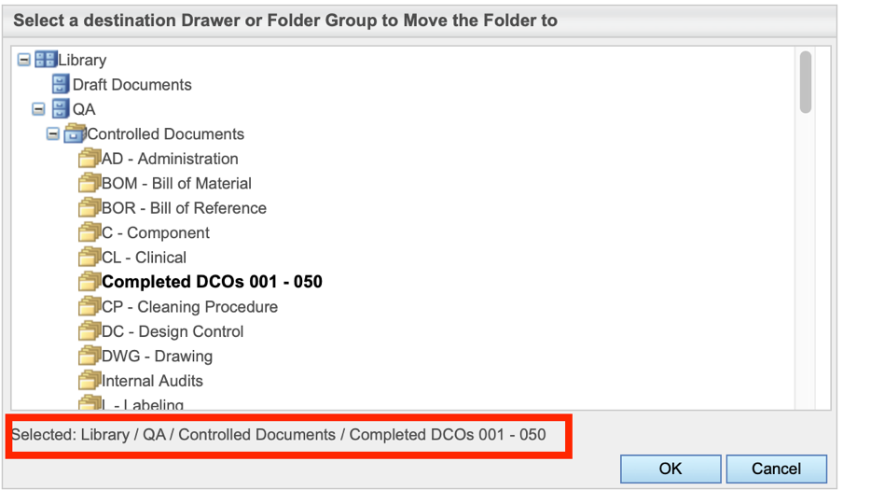

With the DCO folder now moved into the Completed DCOs folder group, right click on the DCO folder and select “Properties” in the menu. In the “Edit DCOxxx Folder” Window that opens, click on the Security link, make sure Current Members of Folder is restricted to proper members able to view this folder (in screenshot below, with the “Current Members of Folder” empty indicates that only system administrators may see the folder). Click Save.

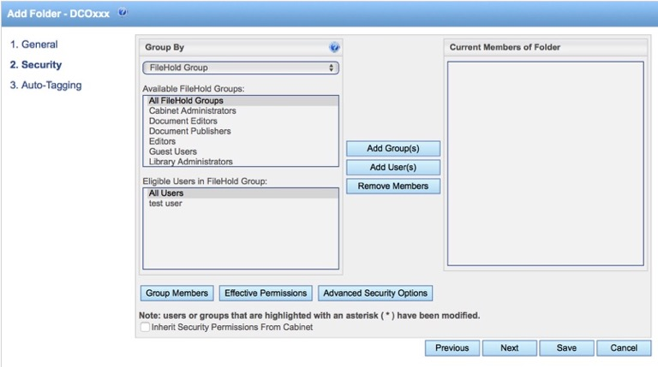

Document administrator goes to the completed DCO folder and converts the DCO form to an electronic record. Right click on the DCO, select “metadata & file properties”. On the “metadata fields” window that opens click “edit”. In the Format of Document drop down, select Electronic Record. At bottom of the Metadata Fields window, click Save.

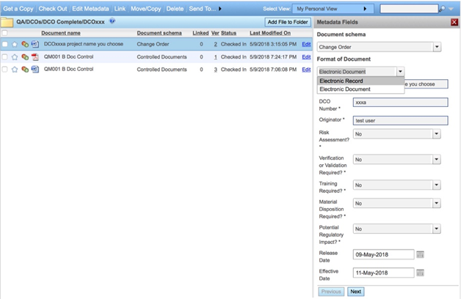

If you haven’t already done so, be sure to delete all copies of documents from your local PC (and the DCO project folder you were working from can also be deleted).

Document administrator is to notifiy parties that have controlled copies of superseded versions that those versions need to be destroyed. Document administrator will replace will the updated versions (add “Controlled Copy” mark). Email confirmation is required that the notification has been received.

Procedure: Initiating and Completing Training Workflow (training coordinator and trainer)

Create employee’s training record. In the date and signature fields type in “View FileHold for sign off evidence” in appropriate fields. Convert the Word document to PDF.

Email trainee’s training record pdf, redlined pdfs of documents to be trained upon (procedures, work instructions, etc.), effectiveness check quiz and other support documents (if applicable).

In FileHold, create trainee training folder(s) with schema set to “quality record” within the Training Workflow group folder. Add training record(s). Create separate training workflow for each employee training record.

If training record is for both Read & Acknowledge and Interactive:

if any have effectiveness check: follow workflow initiation steps in section 14.7.

if no effectiveness check: follow workflow initiation steps in section 14.6.

If training record is for Read and Acknowledge only with no effectiveness checks: Right click on training record to reveal menu. On menu, select workflow > Initiate Training Workflow.

Note: if Certified as Trainer is checked off as “yes” and Originator is checked off as “no” on one or more requirements: follow steps in section 14.6 (instead of adding a trainer, you will need to add the trainee’s supervisor in the “approvers” section).

In the Initiate Workflow window: Update “Workflow Activity 1” with trainee added to “approvers” section. Update “Due By” date as appropriate. Click Ok to initiate the workflow. FileHold will send email notification to trainee alerting them of training signature request.

When email notification from FileHold has been received that trainee has signed, the training record can be moved to trainee’s folder.

If training record is for Read and Acknowledge only and one or more contains an effectiveness check: Right click on training record to reveal menu. On menu, select workflow > Initiate Training Workflow.

Note: if Certified as Trainer is checked off as “yes” and Originator is checked off as “no” on one or more requirements: follow steps in section 14.7 (instead of adding a trainer, you will need to add the trainee’s supervisor in the “approvers” section).

In the Initiate Workflow window: Update “Workflow Activity 1” with trainee added to “approvers” section. Update “Due By” date as appropriate.

Click Ok to initiate the workflow. FileHold will send email notification to trainee alerting them of training signature request.

When email notification from FileHold has been received that trainee has signed, check out training record from FileHold and add graded quiz to training record pdf. On the training record, update the Effectiveness Check section. Check training record back in to FileHold. Move training record to trainee folder.

If training record is for Interactive only with no effectiveness checks: Right click on training record to reveal menu. On menu, select workflow > Initiate Training Workflow.

In the Initiate Workflow window: Update “Workflow Activity 1” with trainee added to “approvers” section. Update “Due By” date as appropriate.

At bottom of window, click “Add Activity” button. This adds section “Workflow Activity 2”. Ensure “approval” is selected in the drop-down button to right. Add title: “Trainer Signature”. Add trainer to the “approvers” section. In the “Options” section, ensure “Require password” box is selected. Update “Due By” date as appropriate. In “Task Instructions” type “trainer to sign off on training record”.

Click Ok to initiate the workflow. FileHold will send email notification to trainee alerting them of training signature request.

Immediately after trainee e-signs, FileHold will automatically send email notification to trainer alerting them of training signature request.

Trainer logs in to FileHold, reviews record for completeness and accuracy. Trainer e-signs.

When email notification from FileHold has been received that training workflow is completed, move training record to trainee folder.

If training record is for Interactive only and one or more contains an effectiveness check: Right click on training record to reveal menu. On menu, select workflow > Initiate Training Workflow. In the Initiate Workflow window: Update “Workflow Activity 1” with trainee added to “approvers” section. Update “Due By” date as appropriate.

Click Ok to initiate the workflow. FileHold will send email notification to trainee alerting them of training signature request.

When email notification from FileHold has been received that trainee has signed, check out training record from FileHold and add graded quiz to training record pdf. On the training record, update the Effectiveness Check section. Check training record back in to FileHold.

Right click on training record to reveal menu. On menu, select workflow > Initiate Trainer Signature workflow.

In the Initiate Workflow window: Update “Workflow Activity 1” with the trainer added to “approvers” section. Update “Due By” date as appropriate.

Click Ok to initiate the workflow. FileHold will send email notification to trainer alerting them of training signature request.

Trainer logs in to FileHold, reviews record for completeness and accuracy. Trainer e-signs.

Immediately after trainer signs, FileHold will automatically send email notification to the training coordinator with an alert that the Trainer Signature workflow has been completed. Training coordinator moves the training record to appropriate trainee folder.

Procedure: How to sign off on Training Workflows (all users)

For Trainees: After all training requirements listed on your training record have been completed (e.g. effectiveness check quiz has been graded and a passing grade was achieved and/or interactive training session has been completed), log in to FileHold and click on “My Tasks”. Next to the appropriate training workflow (if more than one listed), click check box next to “Approve” so it is checked. Click “Complete Task” button. Click green “approve task” button. Enter password and click green “approve task” button.

For Trainers and Supervisors: After receive email notification that you have an “Approve Task Assigned” to sign training record, log in to FileHold and click on “My Tasks”. Next to the appropriate training workflow (if more than one listed), click on the “Show Documents” link along right side of browser window. Open training record in FileHold Viewer (or download a copy) in order to review for completeness and accuracy. To sign off, click check box next to ‘Approve’ so it is checked. Click “Complete Task” button. Click ok. Enter e-signature.

Procedure: How to retrieve Training Programs and Training Records

In FileHold, training programs and training records can be located in LibraryQA – Silq Technologies Corporation cabinet Employee Training drawer employee’s folder.

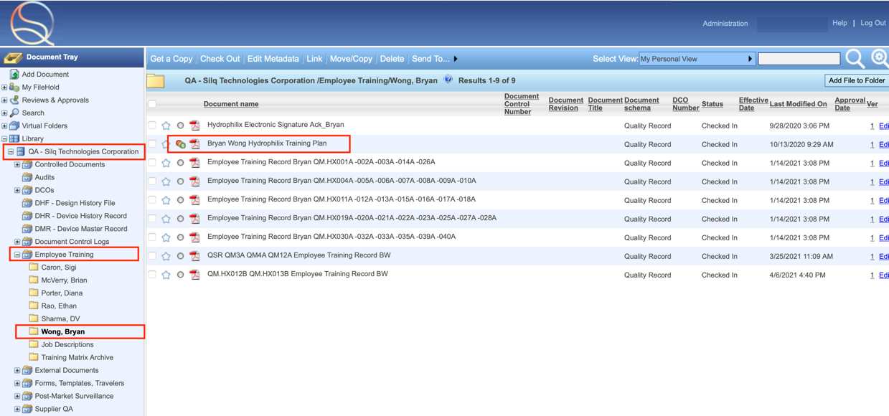

How to View eSignatures on Training Records

Click on ‘ver’ link found next to the training record to open the “History of Document Versions” window.

Click top check box to select record(s). Click “Sign off sheet” button.

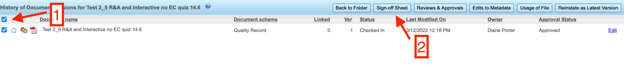

Procedure: Quality System Electronic Signatures (all users)

Each electronic signature shall be unique to each employee and consist of a user identification and password.

Employees will not share any log in information for FileHold.

Employees must complete FM1-QM.SLQ014, Electronic Signature Acknowledgement Form. This form links each individual’s electronic signature to a unique handwritten signature that includes the printed name of the signer, the meaning of the signature, and the date that the handwritten signature was recorded. Once this form is completed electronic signatures are considered equivalent to handwritten signatures.

After completion of form FM1-QM.SLQ014, the Document Administrator shall issue login information.

Completed signature form shall be scanned and imported to employee’s training folder within FileHold.

Appendix 1 – Creating or Changing Document in the SILQ Electronic Document System
Complete DCO form according to QM.SLQ001
Obtain copy of DCO form from ‘Forms, Templates, and Travelers’ drawer
Login into FileHold
To create new document: Obtain a copy of TMP1-QM.SLQ001 from ‘Forms, Templates, and Travelers’ drawer
Create new document using the controlled document template
To change an existing document: Obtain a copy of current document from appropriate drawer located in the ‘QA’ cabinet
Redline a copy of the document with required changes
Email a copy of the completed DCO form to the DA. Attach copies of the new or redlined documents listed in the DCO
New document or change to existing?

Appendix 2 – Review and Approval of a DCO in the SILQ Electronic Document System
Login into FileHold
Select ‘My Tasks’ under ‘Reviews & Approvals’ tab
Locate the applicable DCO task to review and select ‘Show Documents’
Download a local copy of the DCO form and review the contents. See QM.SLQ001.
Download the associated documents included in the DCO task
Based on the DCO form, review the applicable documents (either new or redlines)
Select DCO task and click ‘Complete task’
If changes required or comments need to be addressed:
Provide brief summary in comments section
Attach file of redlined document or if multiple documents email directly to DA
Select ‘Ok’
The comments and redlines will be forwarded to the DCO initiator to address.
If documents are acceptable, select DCO task and click ‘Complete task’
Select ‘I Approve This Document’ and click ‘Ok’
Select ‘I Postpone Approval of This Document’
An incremental DCO will be re-routed once the changes and/or comments have been addressed [Workflow restarted]

Appendix 3 – Initiating a Training Workflow in the SILQ Electronic Document System

TC emails trainee a copy of their training record and any supporting documentation (e.g., training material, effectiveness quizzes, etc.)
TC: Create temporary folder(s) for employee(s) in FileHold. Add original training record(s) to temporary folder(s)
Trainer e-signs
Yes
Training coordinator (TC) creates employee training record

Is Type of Training set to Interactive?
No

Yes
Yes
Trainee e-signs
Does training record require an Effectiveness Check?
TC: Check out original training record and append quiz to training record. Complete Effectiveness Evaluation box on training record. Check in training record.
TC moves training record to trainee’s folder
No
Initiate Trainer Signature Workflow
Is employee the Document Originator?
No
TC: Initiate Training Workflow

